International School of Pediatric Sciences
Director: Lorenzo Moretta

Scientific Organizing Committee
Armando Cama
Valeria Capra
Patrizia De Marco
Elisa Merello
Rick Finnell

Local Organizing Committee
Armando Cama
Valeria Capra
Patrizia De Marco
Samantha Mascelli
Elisa Merello
GianLuca Piatelli
Alessandro Raso
Neurosurgery Unit, G. Gaslini Institute
16148 Genoa, Italy
Tel.: +39 010 5636604
valeriacapra@ospedale-gaslini.ge.it

Organizing Secretariat
Maria Caterina Cogorno
International School of Paediatric Sciences
G. Gaslini Institute, Genoa.
Tel.: +39 010 5636.554 or .805
Fax: +39 010 3776590
caterinacogorno@ospedale-gaslini.ge.it

Information

Registration
The meeting is open to neurosurgeons, pediatricians, biologists and medical genetists.
30 applicants will be admitted.

Deadline for registration: August 25, 2008
Fill in the attached form and return it to the organizing secretariat.

Registration fees:
The fee of euros 300,00 (150,00 for students and post-docs under 30) covers: access to scientific sessions, abstracts, 3 coffee breaks, 1 lunch, 2 dinners, 2 nights B&B and attendance certificate.

Official language: English

Venue
Villa Quartara, Badia Benedettina della Castagna
Via Romana della Castagna, Genoa, Italy.

How to reach the venue
Plane: from the International Airport Cristoforo Colombo, shuttle bus n. 100 (runs every hour) takes you to Genova Principe railway station, where you can take a taxi to Via Romana della Castagna.
Train: get off at Genova Brignole railway station, take bus n. 17 and get off in Corso Europa, in front of Via Romana della Castagna.
Car: motorway exit Genova-Nervi, take Corso Europa westwards, take the overpass and drive eastwards, pass Hotel AC and ESSO gas station on the right, after 50 mt. turn right into Via Romana della Castagna, go straight 80 mt., enter the gate on the right leaving the church on the left and follow signs for parking.

Accommodation
Please make your arrangement well in advance.
Special rates have been arranged at the Hotel AC****Genova-Quarto +39-010-3071180 located at walking distance from the Badia. Other suggested hotels:
Hotel Iris*** Genova-Quarto +39-010-3773914
Hotel Astor****Genova-Nervi +39-010-329011
Always mention the NDTs meeting.

Italian CME credits
Italian CME credits for medical doctors (pediatrics, neurosurgery, medical genetics) and biologists: 11
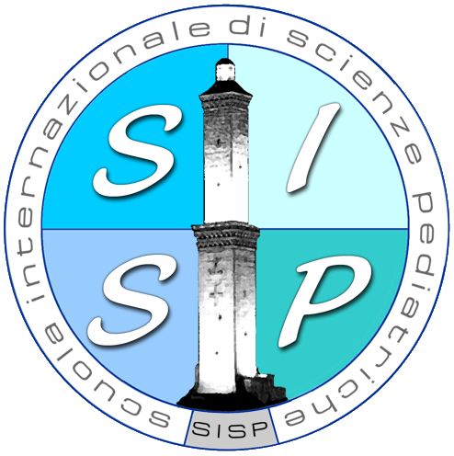

Advanced Genetic Perspectives in Neural Tube Defects.
2nd Meeting

Lija Slutskaja - Sintesi di Genova, 1934 (detail)

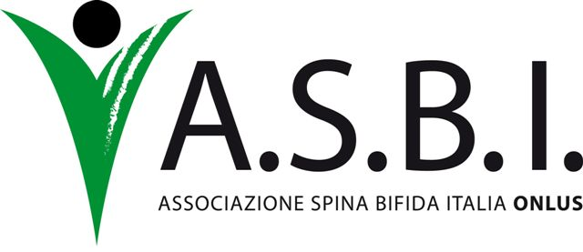
under the auspices of the Italian Society of Pediatrics (SIP) and the Italian Society of Human Genetics (SIGU)

September 27-28, 2008 Genoa, Italy


Istituto Giannina Gaslini

Aims of the meeting
Although Neural Tube Defects (NTDs) are one of the most common human congenital anomalies, their etiology is still imperfectly understood. On September 27th and 28th, 2008, we will be uniting some of the most prominent NTD scientists in Genoa, Italy for a two-day meeting to explore the most relevant and recent scientific findings and advances in this field. Second in a planned annual series of gatherings, this meeting will showcase up-to-date information, providing as well a wealth of background knowledge about these complex developmental anomalies, thereby giving early stage researchers the chance to share in and benefit from the most recent data emerging in the field.
Through a format designed to stimulate discussion and scientific exchange, the meeting will highlight the mechanisms involved in the pathogenesis of NTDs. In particular, attention will be focused on the most recent advances in the mechanisms of neural tube formation and vertebrate embryology, with special emphasis being given to efforts to translate these findings from animal models to the identification of human NTD risk genes. The meeting’s overriding goal is to offer a scientific program that meets the needs and interests of young researchers and students in biology, as well as medical geneticists, pediatricians and neurologists working in the field.

September 27, 2008

13,30 Registration
14,15 Welcome address

1st Session
Chair: Andrew Copp

14,30 Nick Greene
Gene environmental interactions in the causation of neural tube defects. Investigating the role of folate status
15,00 Steve Whitehead
Genetic determinants of folate phenotypes and markers of inflammations: implications for spina bifida risk
15,30 Rick Finnell
Maternal immune responses as Neural Tube Defect risk factor
16,00 Discussion

16.15 Coffee break

16,45 Gabriela Pavlinkova
Maternal diabetes affects transcriptional programs in the developing embryo
17,15 Amber Marean
Folic acid supplementation is detrimental in the 3Poly NTD mouse mutant
17, 45 Henk Blom
Changes in gene expression due to
inhibition of methylation in a neural tube defect model
18,00 Discussion

September 28, 2008

2nd Session
Chair: Rick Finnell

8,45 Andrew Copp
How does neural plate bend during mammalian neurulation?
9,15 Christina Pyrgaki
Imaging neural tube closure in the mouse embryo
9,45 Valentina Massa
Role of Zic2 in mammalian neural tube closure
10,15 Discussion

10,30 Coffee break

11,00 Sandra De Castro
Proteomic analysis of curly tail, a mouse model for neural tube defects
11,30 Massimo Crippa
Myosin VI: an unconventional protein with unconventional functions
12,00 M.Brouns
Critical roles for Granyhead like genes in caudal neural tube closure
12,30 Discussion

12,45 Lunch

3rd Session
Chair: Henk Blom

14,00 Heather McDermid
CECR2: a mouse model for anencephaly
14,30 Andrea Rossi
The end result: neuroradiology of spinal dysraphism and congenital caudal anomalies
15,00 Giuseppe Martucciello
Hindgut malformations in Caudal Regression Syndrome
15,30 Patrizia De Marco
Caudal regression and Currarino syndromes: oligogenic disorders
16,00 Discussion

16,15 Coffee break

16,45 Zoha Kibar
Identification of VANGL1 variants associated with neural tube defects

17,15 Discussion

17,30 Closing remarks

18.00 Quality assessment and CME tests

